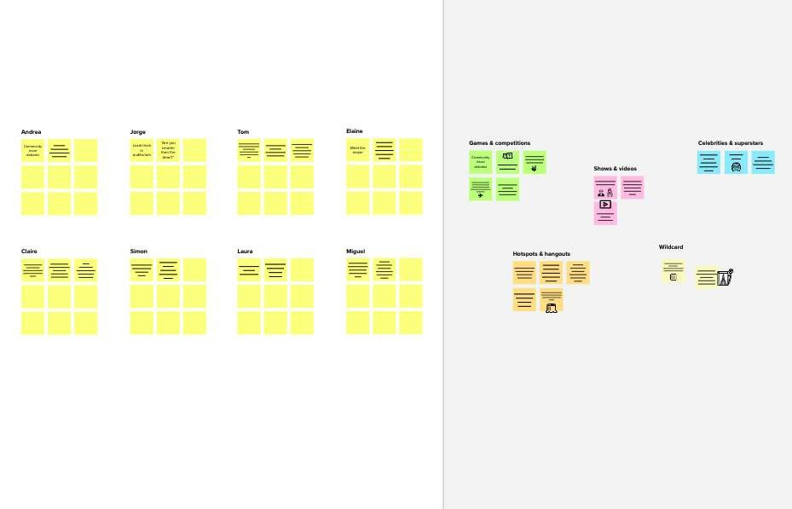

**PROBLEM**

**How might the Biodiversity**

**Species of Flora and Fauna In Some Wild Spaces For his Research Purpose?**

**researcher Ide**.**ntify Different**

# Brainstorm

## 1

**Define your problem statement**

### What problem are you trying to solve? Frame your problem as a How Might We statement. This will be the focus of your brainstorm.

**5 minutes**

**2**

**Brainstorm**

Write down any ideas that come to mind that address your problem statement.

**10 minutes**

**3**

**Group ideas**

### Take turns sharing your ideas while clustering similar or related notes as you go. Once all sticky notes have been grouped, give each cluster a sentence-like label. If a cluster is bigger than six sticky notes, try and see if you and break it up into smaller sub-groups.

**TIP**

You can select a sticky note and hit the pencil [switch to sketch] icon to start drawing!

**20 minutes**

**4**

**Prioritize**

Your team should all be on the same page about what's important moving forward. Place your ideas on this grid to determine which ideas are important and which are feasible.

**20 minutes**

**& idea prioritization**

e this template in your own brainstorming sessions so your team can unleash their imagination and tart shaping concepts even if you're not sitting in the same room.

**S.Hasful Yasar**

|  |  |  |
| --- | --- | --- |
| To collect The Flower,plants and Animal Species images | Use Image Classification | To Build CNN model |
| To test the CNN model using the another images | To Predict The Flower and Plant spcies | To Predict The Animals Species |
| Save and implement the model in Web App | To Build Web app using Flask | Upload the image in Web app |

**J.Jerald Raj**

|  |  |  |
| --- | --- | --- |
| To Collect all the Flora And Fauna species images | Use Computer Vision | Build the Computer Vision model |
|  |  | To Detect |
| Create the | To implement | Flora and |
| mobile app | that Model | fauna |
|  |  | Species |
|  | This could be | It could detect |
| And identify those Species | a Handy tool for Bio diversity | only the learned objects |

**Category 1**

Build the Computer Vision model

To Collect all the Flora And Fauna species images

To Build CNN model

To Create a web Application

The database Are stored with all images

**Category 4**

The database Are stored with all images

To collect The Flower,plants and Animal Species images

To test the CNN model using the another images

To Predict The Animals Species

To Build Web app using Flask

To Predict The Flower and Plant spcies

Save and implement the model in Web App

To Build CNN model

Save and implement the model in Web App

To Detect Flora and fauna Species

Upload the image in Web app

And identify those Species

To Detect Flora and fauna Species

To make category

To Predict The Flower and Plant spcies

**10 minutes** to prepare

To identify using object identification

**1 hour** to collaborate

**S.Nithis Kumar**

The database Are stored with all images

**Kesavan**

**Category 2**

To Predict The Animals Species

To Build CNN model

And identify those Species

**2-8 people** recommended

To Create a web Application

**Key rules of brainstorming**

#### To run an smooth and productive session

To Create a web Application

To upload the images of any species

That contains a Data base

To store and retrieve from the database

To Collect the Species images

To Calssify the different species

Use Data Visualization using python

That will looks the web attractive

To visualize the Flora and fauna Species

The analytics are display about the species

To Create a web Application

To Calssify the different species

The database Are stored with all images

Use Image Classification

The analytics are display about the species

To visualize the Flora and fauna Species

#### Stay in topic. Defer judgment.

The database retrieve that image information

Encourage wild ideas. Listen to others.

**Category 3**

**Importance**

If each of these tasks could get

To Create a web Application

To visualize the Flora and fauna Species

To Detect Flora and fauna Species

Use Computer Vision

Build the Computer

Save and implement the model in Web App

Go for volume. If possible, be visual.

To Calssify the different species

done without any difficulty or cost, which would have the most positive impact?

To Collect all the Flora And Fauna species images

To visualize the Flora and fauna Species

To collect the videos of Flora and fauna

Vision model

The database Are stored with all images

To Calssify the different species

[**Share template feedback**](https://muralco.typeform.com/to/CiqaHVat?typeform-source=app.mural.co)

**Feasibility**

Regardless of their importance, which tasks are more feasible than others? (Cost, time, effort, complexity, etc.)

**Template**

**Need some inspiration?**

See a finished version of this template to kickstart your work.

[**Open example**](https://app.mural.co/template/e5a93b7b-49f2-48c9-afd7-a635d860eba6/93f1b98d-b2d2-4695-8e85-7e9c0d2fd9b9)

|  |  |  |  |  |
| --- | --- | --- | --- | --- |
|  |  |  |  |  |